Agenda for 3rd Sep Meeting

1. Pico W’s RP2040 dual core architecture

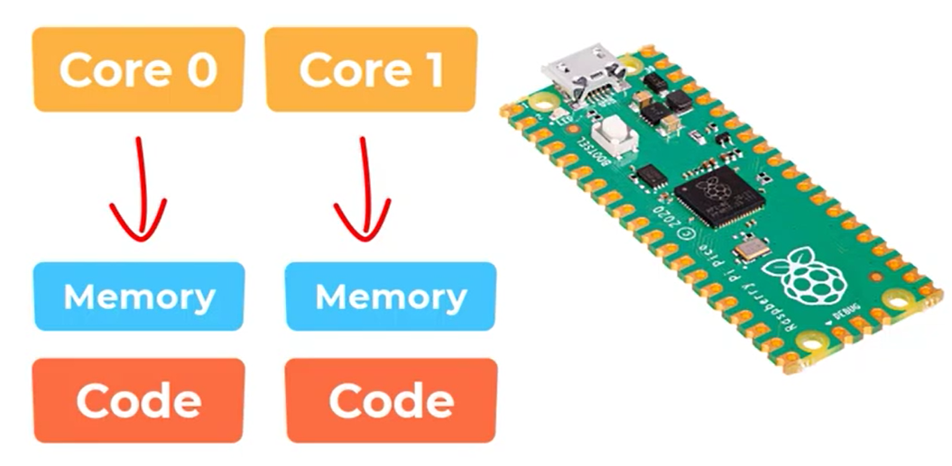

**CORE 0 is the default core**

1. Multithreading and Demonstration (countingwithoutthready.py and countingwiththread.py)

* Parallel execution
* Parallel processing
* Multi-tasking

1. <https://youtu.be/Qdu6ixPz43o?si=NW2dNdkILtQ22EOF> to find out more about the architecture.
2. Why autorobot.py is not efficient and how multithreading can solve this problem
3. Practical work.